Import Data using Transform Maps (Spreadsheet)
Milestone 1 : Creation Of Spreadsheet And Table
Creation Of Spreadsheet
The spreadsheet data will be uploaded into a ServiceNow Import Set Table, where it will be validated and transformed before being inserted or updated in the target banking table using a Transform Map.
Prepare the sheets
1. New Google Spreadsheet
2.Create New Google Spreadsheet with sample data as shown below

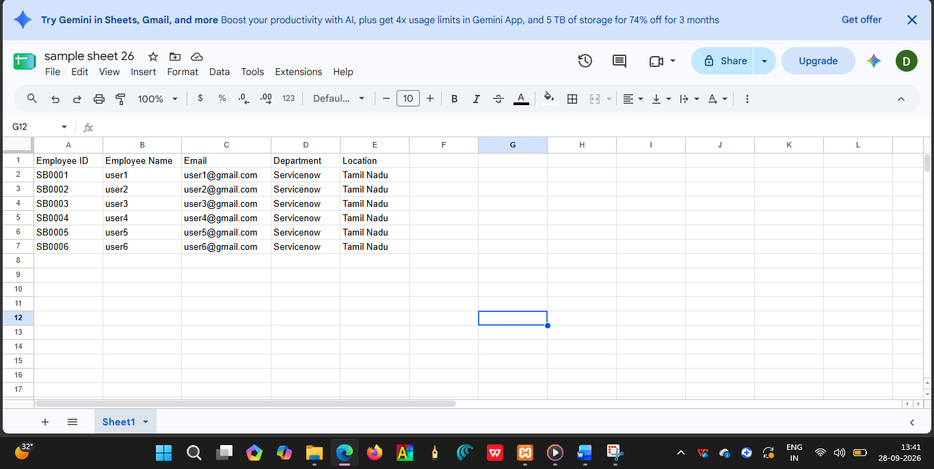

3.Download the spreadsheet as Sample Spreadsheet.xlsx format.

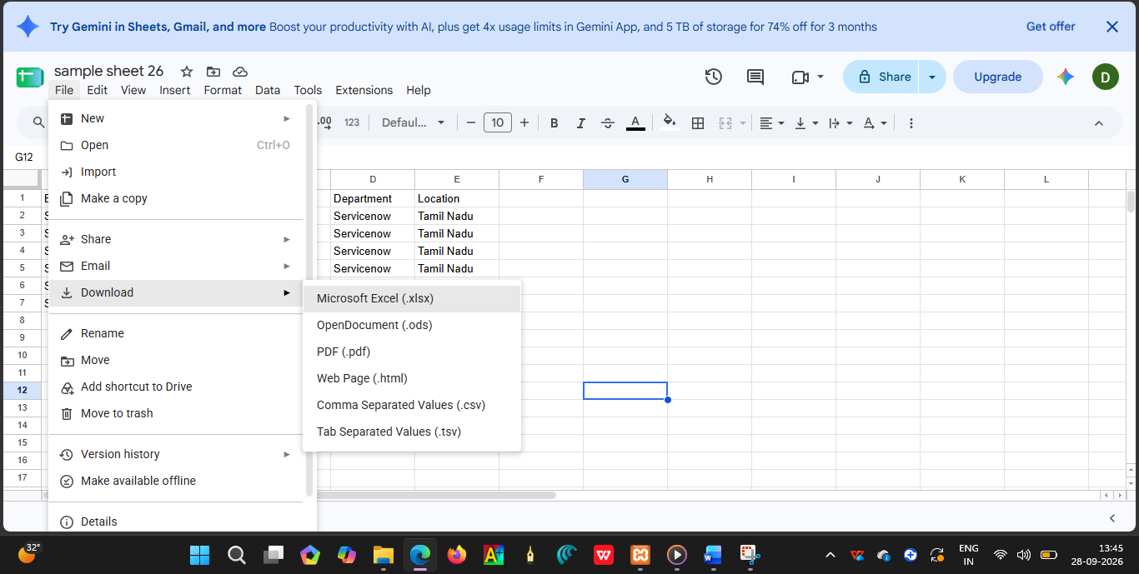

Creation of Tables
The Import Set Table acts as a temporary staging table for the data uploaded from the spreadsheet. The imported spreadsheet records are stored here before transformation.

Create new Custom table
Navigation:

1.Tables > Create New

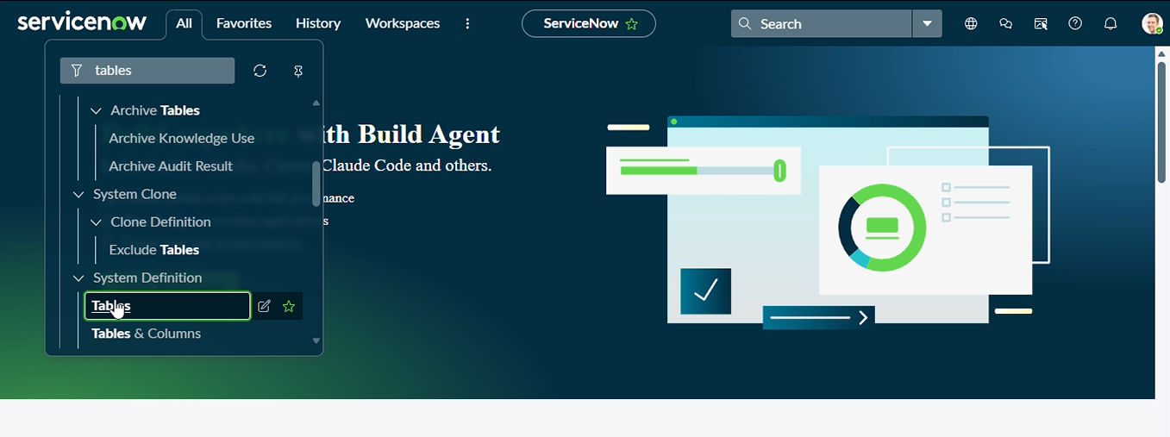
2.Label: Employee Test Name: u_employee_test
3.After creating and saving the Employee Test table
4.scroll down and go to related links
5.click on show form

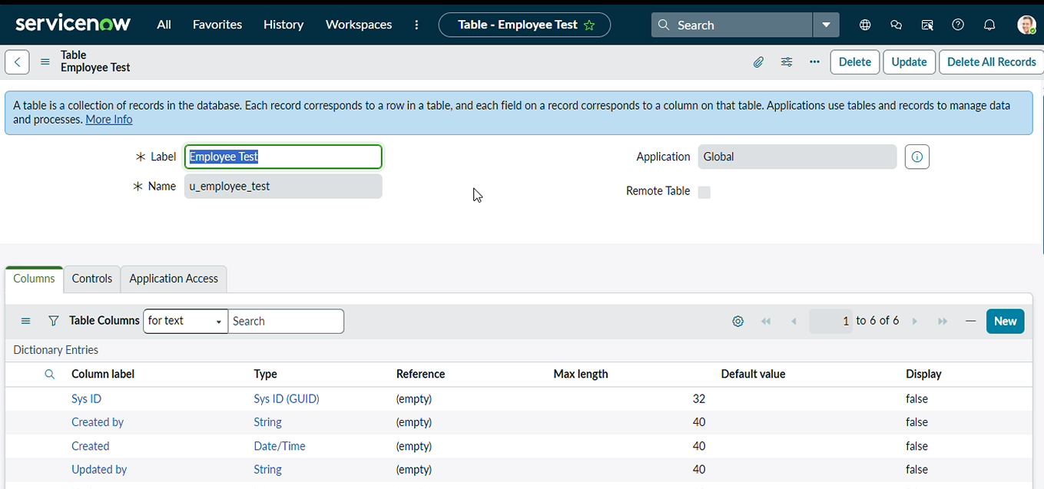
6.On the form, locate the Form Context Menu / Additional Actions option on the left side of the form header.\
7.Click the Form Context Menu / Additional Actions icon.
8.Click configure , select Form Layout.

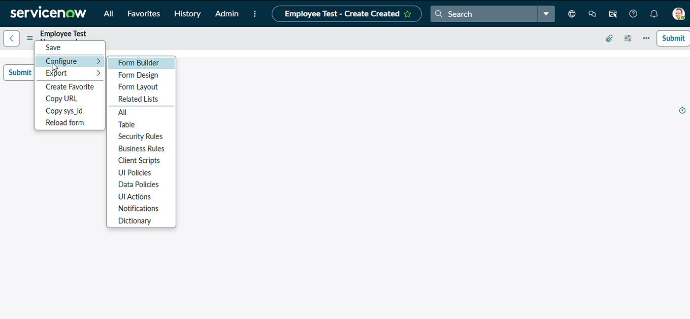
9.The Form Layout page will open, where you can configure the fields displayed on the form
10.After opening Form Layout, click New to create a new field.
11.Enter the field details:
Column Label: Employee ID
Type: String
Click Add to create the field.
12.Repeat the same steps to create the following fields:
Employee Name – Type: String
Email – Type: String
Department – Type: String
Location – Type: String
13.After creating all the required fields, click Save.
14.Verify that the newly created fields are displayed on the Employee Test form
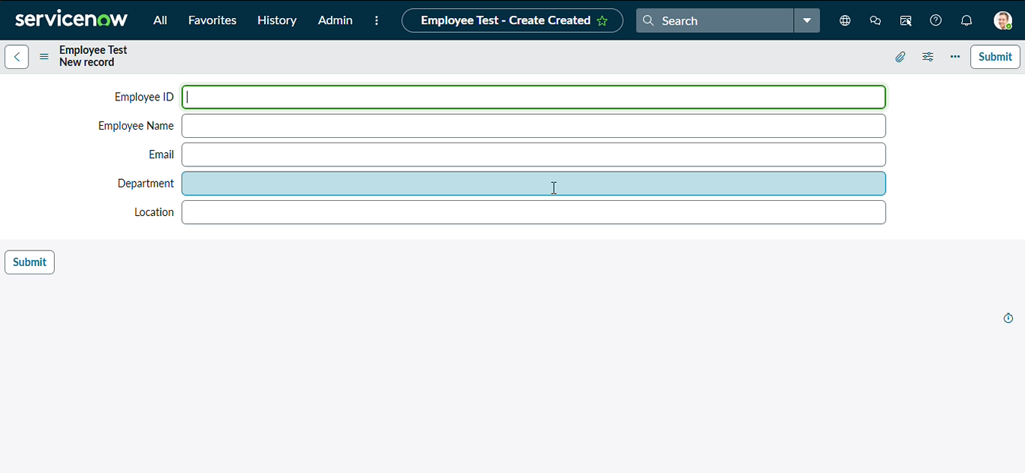

15.Click on Submit or Save

